🏠 HOUSE PRICE PREDICTION
Complete Machine Learning Project Documentation
Regularization • Cross-Validation • Tree Models • SVR • Model Evaluation

Document Item | Details
Project Type | Supervised Machine Learning — Regression
Programming Language | Python
Primary Libraries | Pandas, NumPy, Matplotlib, Scikit-learn
Target Variable | house_price_inr
Models | Ridge, Lasso, Decision Tree, Random Forest, SVR
Evaluation | MSE, MAE, RMSE, R²
Source Notebook | 0e58340e-1ce1-48f1-9a67-70f29eb4c496.ipynb

1. Executive Summary
This project develops an end-to-end house-price regression workflow in Python. The supplied notebook is organized into Parts B–H and covers data preparation, Ridge and Lasso regularization, cross-validation strategies, tree-based regression, Support Vector Regression, final model comparison, overfitting analysis, and business interpretation.
The project compares several model families and selects a final model using test-set error and R². The supplied final evaluation CSV identifies Lasso as the best-performing model by the lowest test RMSE.

Project Workflow
- Load and inspect the house-price dataset.
- Convert sale_date and derive sale_year and sale_month.
- Separate the target variable from predictor features.
- Split the data into training and testing sets.
- Standardize features for scale-sensitive models.
- Train Ridge and Lasso regression models.
- Tune regularization strength using cross-validation.
- Compare K-Fold, Stratified K-Fold, LOOCV and Time Series Split.
- Train Decision Tree and Random Forest models.
- Train Linear and RBF SVR models and tune C, gamma and epsilon.
- Compare all models using MSE, MAE, RMSE and R².
- Analyze overfitting/underfitting and document the final recommendation.

2. Part A — Conceptual Foundation (Theory)
The following answers follow the terminology and questions shown in the supplied Part A task.

1. What is Regularization in Machine Learning? Why is it needed?
Regularization is a technique used to control model complexity by adding a penalty for large model coefficients to the loss function. It helps reduce overfitting, improve generalization on unseen data, and make the model less sensitive to noise.

2. Difference between Ridge Regression (L2) and Lasso Regression (L1).
Ridge Regression uses an L2 penalty, which shrinks coefficients toward zero but normally keeps all features. Lasso Regression uses an L1 penalty and can shrink some coefficients exactly to zero, so it can also perform feature selection.

3. What is Cross-Validation and why is it important?
Cross-Validation repeatedly divides data into training and validation portions. It provides a more reliable estimate of model performance, helps detect overfitting, and supports model and hyperparameter selection.

4. K-Fold Cross-Validation
The dataset is divided into K folds. The model trains on K−1 folds and validates on the remaining fold, repeating until every fold has been used for validation.

4. Stratified K-Fold Cross-Validation
Stratified K-Fold keeps the class distribution approximately consistent across folds. In this regression project, target values are first divided into five bins so stratified splitting can be applied.

4. Leave-One-Out Cross-Validation (LOOCV)
One observation is kept for validation while all other observations are used for training. This is repeated for every observation. The notebook uses the first 100 training observations to keep LOOCV practical.

4. Time Series Split
Data is divided chronologically. Training uses earlier observations and validation uses later observations, preventing future information from being used to predict the past.

5. Why are tree-based models less sensitive to feature scaling?
Tree-based models make decisions using feature thresholds. Because the split depends mainly on ordering and thresholds rather than distances or coefficient magnitude, changing feature scale usually does not change the tree's decisions.

3. Dataset and Feature Definition
The notebook reads House_Price_Dataset.csv and uses sale_date to create two additional time features. The target is house_price_inr.
Feature | Role / Meaning
area_sqft | Property area in square feet
bedrooms | Number of bedrooms
bathrooms | Number of bathrooms
location_score | Location quality score
property_age | Age of property
distance_city_km | Distance from city center
near_school | School proximity indicator
near_metro | Metro proximity indicator
crime_rate_index | Crime-rate index
sale_year | Year extracted from sale_date
sale_month | Month extracted from sale_date
house_price_inr | Target variable / predicted house price

4. Part B — Data Preparation and Feature Scaling

Task 1–8: Workflow
- Import Pandas, NumPy and Scikit-learn components.
- Read House_Price_Dataset.csv.
- Inspect dataset shape and first five rows.
- Check data types and missing values.
- Convert sale_date using the format %d-%m-%Y.
- Create sale_year and sale_month.
- Set house_price_inr as y and select 11 predictor features as X.
- Perform an 80/20 train-test split with random_state=42.
- Fit StandardScaler only on the training data and transform the test data using the same scaler.
Key preprocessing code:
df["sale_date"] = pd.to_datetime(df["sale_date"], format="%d-%m-%Y")
df["sale_year"] = df["sale_date"].dt.year
df["sale_month"] = df["sale_date"].dt.month

X_train, X_test, y_train, y_test = train_test_split(
X, y, test_size=0.20, random_state=42
)

scaler = StandardScaler()
X_train_scaled = scaler.fit_transform(X_train)
X_test_scaled = scaler.transform(X_test)

5. Part C — Regularized Linear Regression

Task 9 — Ridge Regression (L2)
The notebook trains Ridge(alpha=1.0), produces training/test predictions, calculates RMSE and R², and then tunes alpha using RidgeCV.

Task 10 — Lasso Regression (L1)
The notebook trains Lasso(alpha=1.0, max_iter=100000), calculates training/test RMSE and test R², and tunes alpha using LassoCV.

Task 11 — Alpha Tuning
Both models use 50 logarithmically spaced alpha candidates from 10⁻³ to 10³ with 5-fold K-Fold cross-validation.

Task 12 — Ridge vs Lasso
The notebook compares training, validation and test RMSE, test R², and coefficient behavior. It also counts zero Lasso and Ridge coefficients and produces two comparison charts.
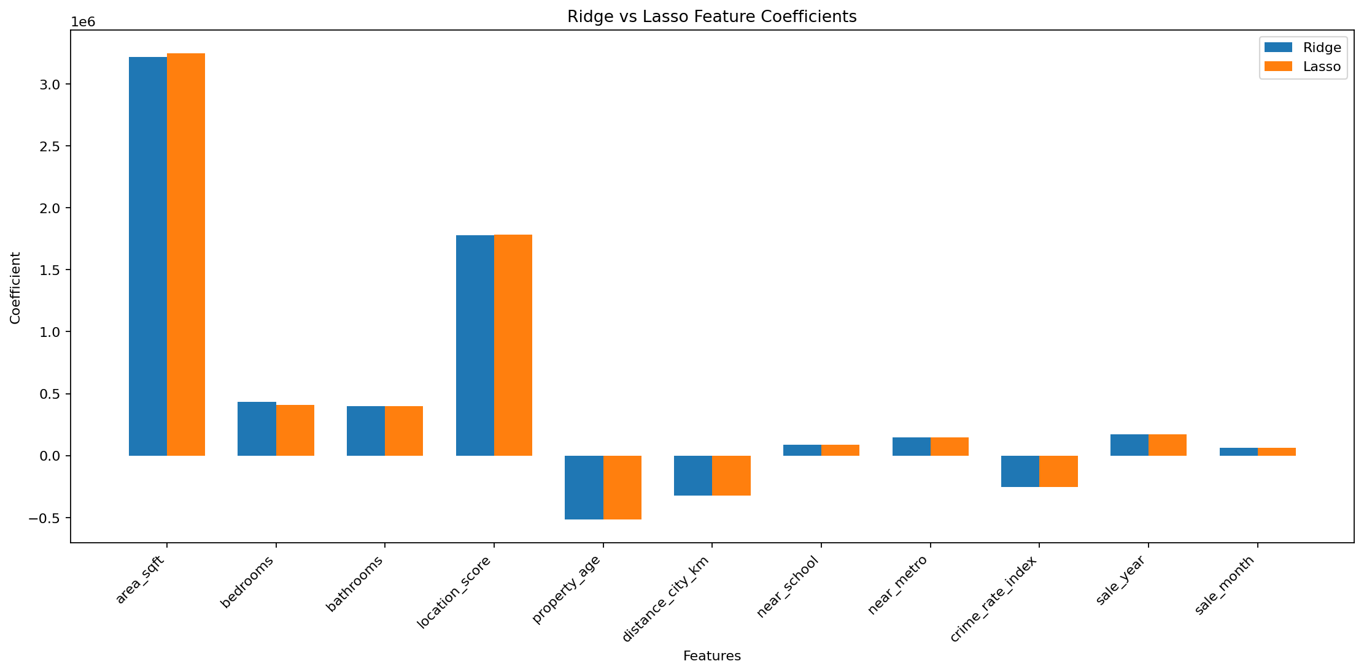
Figure: Ridge vs Lasso Feature Coefficients
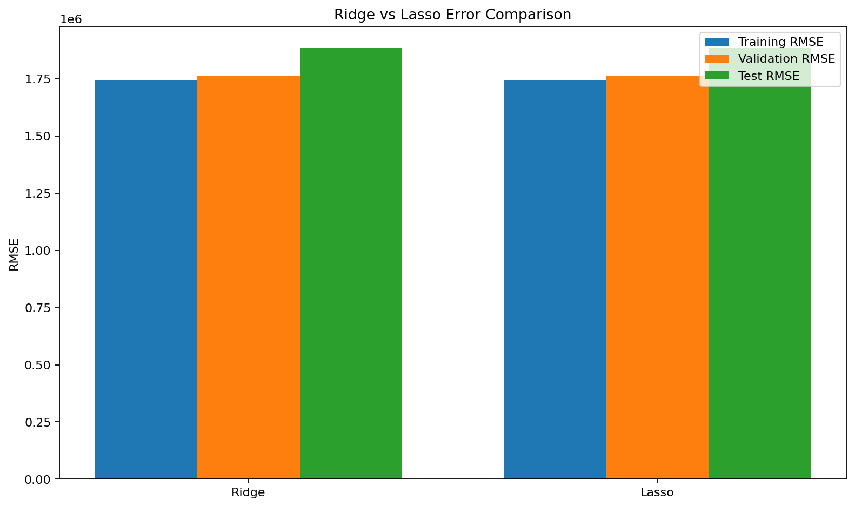
Figure: Ridge vs Lasso Error Comparison

6. Part D — Cross-Validation Strategies

Task 13
- K-Fold Cross-Validation: 5 folds, shuffled, random_state=42.
- Stratified K-Fold: target is converted into 5 quantile bins before stratification.
- Leave-One-Out: applied to the first 100 training observations for practicality.
- Time Series Split: 5 chronological splits.

Task 14 — Performance Analysis
For every strategy the notebook calculates RMSE, MAE and R². It then identifies the strategy with the lowest RMSE, lowest MAE and highest R².
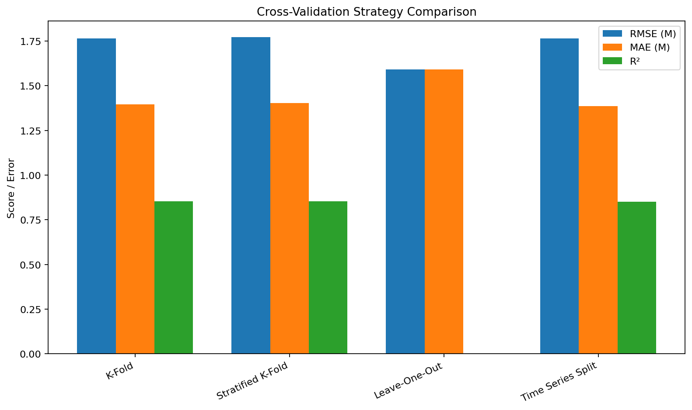
Figure: Cross-Validation Comparison

7. Part E — Tree-Based Regression Models

Task 15 — Decision Tree Regression
A DecisionTreeRegressor(random_state=42) is trained. Training RMSE and test RMSE/MAE/R² are calculated.

Task 16 — Control Tree Complexity
A controlled tree uses max_depth=5, min_samples_split=10 and min_samples_leaf=5 to reduce unnecessary model complexity.

Task 17 — Random Forest Regression
A RandomForestRegressor with 100 trees, random_state=42 and n_jobs=-1 is trained and evaluated.

Task 18 — Decision Tree vs Random Forest
The notebook builds a comparison table containing training RMSE, test RMSE, test MAE and test R², then identifies the lower-RMSE model.
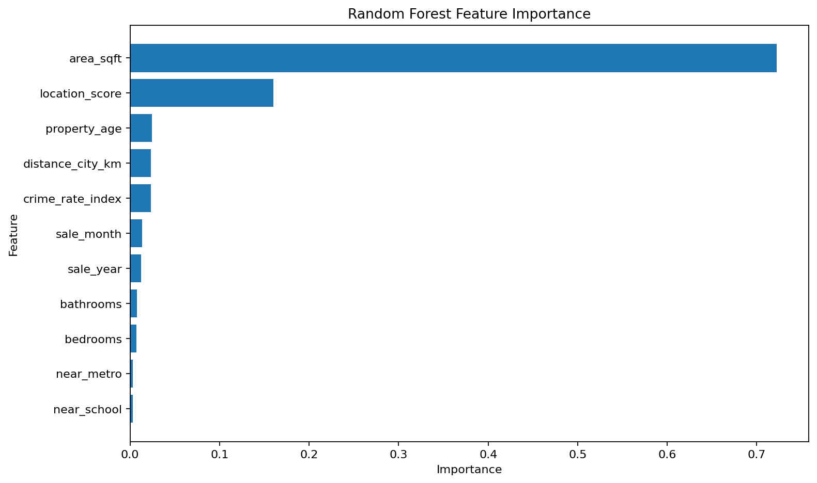
Figure: Random Forest Feature Importance

8. Part F — Support Vector Regression

Task 19 — Linear and RBF SVR
The notebook evaluates SVR with a linear kernel and an RBF kernel. Both use C=100 and epsilon=0.1; the RBF model uses gamma='scale'.

Task 20 — Hyperparameter Tuning
GridSearchCV with 5-fold cross-validation searches C in [10,100], gamma in ['scale',0.01,0.1], and epsilon in [0.1,0.5].

Task 21 — SVR Comparison
The three SVR variants are compared using MSE, MAE, RMSE and R².

9. Part G — Model Comparison and Evaluation

Task 22 — Final Metrics
Predictions from Ridge, Lasso, Decision Tree, Random Forest, SVR Linear, SVR RBF and SVR Tuned are evaluated with MSE, MAE, RMSE and R².

Task 23 — Model Groups
Group | Models
Regularized Linear | Ridge, Lasso
Tree-Based | Decision Tree, Random Forest
SVR | SVR Linear, SVR RBF, SVR Tuned

Task 24 — Overfitting / Underfitting
The project compares training and test R² and calculates the R² gap. The supplied analysis CSV labels each model according to its observed fit behavior.

10. Final Results
Model | MSE | MAE | RMSE | R²
Lasso | 3,545,472,979,812 | 1,524,311 | 1,882,943 | 0.8596
Ridge | 3,548,456,045,870 | 1,525,185 | 1,883,735 | 0.8595
Random Forest | 3,996,136,618,727 | 1,622,119 | 1,999,034 | 0.8417
Decision Tree | 9,342,295,526,916 | 2,458,261 | 3,056,517 | 0.6300
SVR Linear | 23,955,632,175,094 | 4,052,338 | 4,894,449 | 0.0512
SVR RBF | 25,307,182,742,606 | 4,172,017 | 5,030,624 | -0.0023
SVR Tuned | 25,307,182,742,606 | 4,172,017 | 5,030,624 | -0.0023

According to the supplied final evaluation CSV, <b>Lasso</b> has the lowest test RMSE (1,882,943) and a test R² of 0.8596.

11. Overfitting and Underfitting Analysis
Model | Train R² | Test R² | R² Gap | Status
Ridge | 0.8591 | 0.8595 | -0.0004 | Good Fit
Lasso | 0.8591 | 0.8596 | -0.0005 | Good Fit
Decision Tree | 1.0000 | 0.6300 | 0.3700 | Overfitting
Random Forest | 0.9760 | 0.8417 | 0.1343 | Good Fit
SVR Linear | 0.0566 | 0.0512 | 0.0054 | Underfitting
SVR RBF | 0.0015 | -0.0023 | 0.0038 | Underfitting
SVR Tuned | 0.0015 | -0.0023 | 0.0038 | Underfitting

The supplied analysis labels Ridge and Lasso as Good Fit, Decision Tree as Overfitting, Random Forest as Good Fit, and the SVR variants as Underfitting.

12. Part H — Final Analysis and Reporting

Task 25.1 — Best Performing Model
The notebook selects the model with the minimum RMSE from the final comparison table.

Task 25.2 — Impact of Regularization
Ridge and Lasso reduce model complexity by penalizing large coefficients. Lasso may additionally perform feature selection through zero coefficients.

Task 25.3 — Cross-Validation Stability
Cross-validation is used to compare performance across different data splits and assess stability.

Task 25.4 — Linear vs Non-Linear Models
The notebook groups Ridge, Lasso and Linear SVR as linear models, while Decision Tree, Random Forest, RBF SVR and Tuned SVR are treated as non-linear models.

Task 25.5 — Business Interpretation
- Lower RMSE and MAE indicate lower prediction error.
- Higher R² indicates that more target variation is explained.
- Regularized models help control model complexity.
- Tree-based models can capture non-linear relationships.
- SVR can model linear or non-linear relationships depending on its kernel.
- The model with the lowest test RMSE is selected as the best-performing model.

13. Generated Visualizations
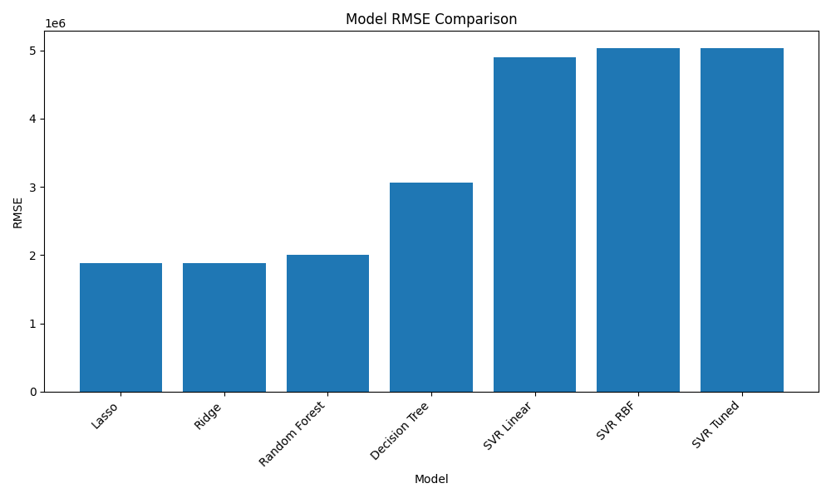
Model RMSE Comparison
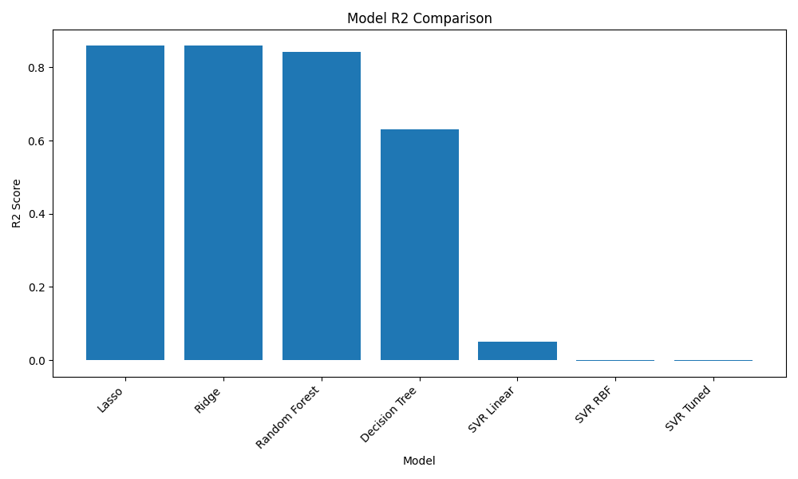
Model R² Comparison
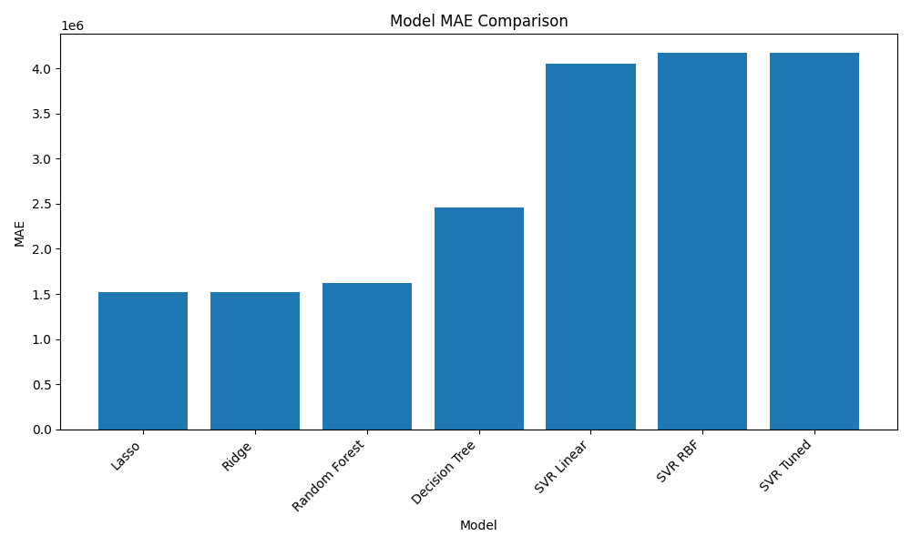
Model MAE Comparison
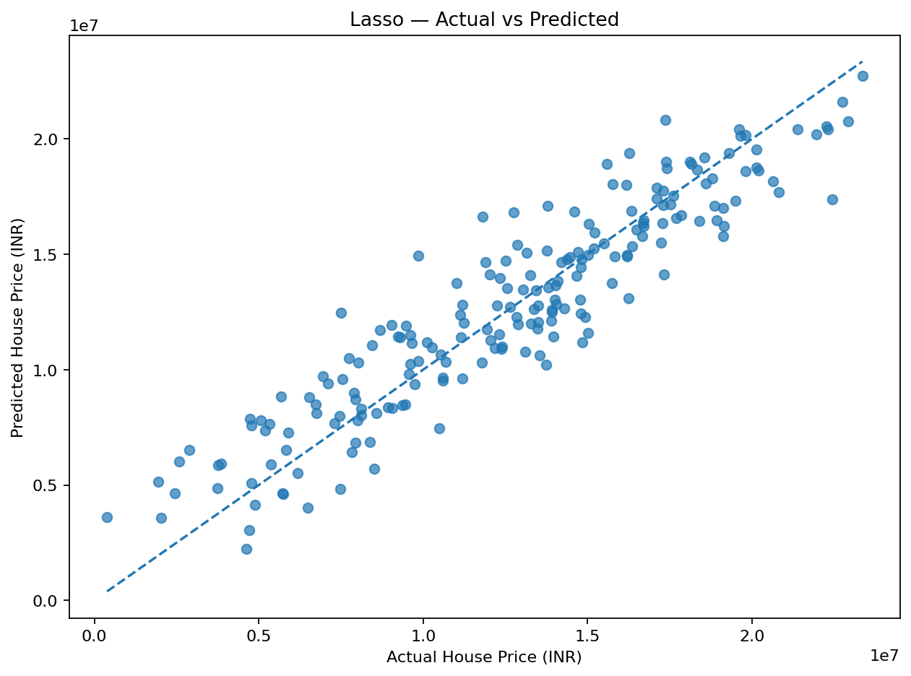
Lasso Actual vs Predicted

14. Project File Structure
House_Price_Regression_Project/
│
├── House_Price_Dataset.csv
├── House_Price_Regression_Complete.ipynb
├── house_price_regression.py
├── requirements.txt
├── run_project.bat
├── README.md
├── project_results.gif
│
├── Ridge_vs_Lasso_Coefficients.png
├── Ridge_vs_Lasso_Error_Comparison.png
├── Cross_Validation_Comparison.png
├── Random_Forest_Feature_Importance.png
├── H_RMSE_Comparison.png
├── H_R2_Comparison.png
├── H_MAE_Comparison.png
├── Lasso_Actual_vs_Predicted.png
│
├── Part_H_Final_Model_Comparison.csv
├── Part_H_Overfitting_Analysis.csv
└── Part_H_Final_Report.txt

15. How to Run the Project
python -m venv venv
venv\Scripts\activate
pip install -r requirements.txt
python house_price_regression.py

# Or open the notebook:
jupyter notebook

16. Interview / Viva Explanation
I developed an end-to-end house price prediction regression project using Python and Scikit-learn. I prepared the dataset, extracted date features, split and scaled the data, trained Ridge and Lasso models, applied cross-validation, built Decision Tree and Random Forest regressors, evaluated Linear and RBF SVR, performed hyperparameter tuning, compared models using RMSE, MAE and R², and analyzed overfitting and underfitting to select the final model.

17. Limitations and Future Improvements
- The project uses a fixed train-test split; repeated or nested validation could provide stronger model-selection evidence.
- Feature engineering can be expanded with interaction terms, log transformations and additional location information.
- The regression target may benefit from transformation if its distribution is strongly skewed.
- More systematic hyperparameter optimization could be performed for tree ensembles and SVR.
- For production use, model monitoring, data validation, versioning and a prediction API would be required.

18. Conclusion
This project demonstrates a complete supervised regression workflow from raw data preparation to model evaluation and reporting. It covers regularization, cross-validation, tree-based learning, SVR, hyperparameter tuning, performance metrics and fit diagnostics. The final supplied evaluation results provide a clear basis for selecting the strongest model while the visualizations make the comparison easy to communicate.

END OF PROJECT DOCUMENTATION

